Date: October 2014

UML Profile for the Global Justice Information Sharing Initiative Global Reference Architecture (GRA-UML)

Version 0.60 (Revised submission in progress)

__________________________________________________
OMG Document Number: gov/2014-??-??
Normative reference: http://www.omg.org/spec/gra-uml/1.0/
Machine readable file(s):
Normative:
Non-normative:
__________________________________________________

Copyright © 2014, IJIS
Copyright © 2014, Model Driven Solutions
Copyright © 2014, Object Management Group, Inc.

USE OF SPECIFICATION - TERMS, CONDITIONS & NOTICES
The material in this document details an Object Management Group specification in accordance with the terms, conditions and notices set forth below. This document does not represent a commitment to implement any portion of this specification in any company's products. The information contained in this document is subject to change without notice.

LICENSES
The companies listed above have granted to the Object Management Group, Inc. (OMG) a nonexclusive, royalty-free, paid up, worldwide license to copy and distribute this document and to modify this document and distribute copies of the modified version. Each of the copyright holders listed above has agreed that no person shall be deemed to have infringed the copyright in the included material of any such copyright holder by reason of having used the specification set forth herein or having conformed any computer software to the specification.
Subject to all of the terms and conditions below, the owners of the copyright in this specification hereby grant you a fully-paid up, non-exclusive, nontransferable, perpetual, worldwide license (without the right to sublicense), to use this specification to create and distribute software and special purpose specifications that are based upon this specification, and to use, copy, and distribute this specification as provided under the Copyright Act; provided that: (1) both the copyright notice identified above and this permission notice appear on any copies of this specification; (2) the use of the specifications is for informational purposes and will not be copied or posted on any network computer or broadcast in any media and will not be otherwise resold or transferred for commercial purposes; and (3) no modifications are made to this specification. This limited permission automatically terminates without notice if you breach any of these terms or conditions. Upon termination, you will destroy immediately any copies of the specifications in your possession or control.

PATENTS
The attention of adopters is directed to the possibility that compliance with or adoption of OMG specifications may require use of an invention covered by patent rights. OMG shall not be responsible for identifying patents for which a license may be required by any OMG specification, or for conducting legal inquiries into the legal validity or scope of those patents that are brought to its attention. OMG specifications are prospective and advisory only. Prospective users are responsible for protecting themselves against liability for infringement of patents.

GENERAL USE RESTRICTIONS
Any unauthorized use of this specification may violate copyright laws, trademark laws, and communications regulations and statutes. This document contains information which is protected by copyright. All Rights Reserved. No part of this work covered by copyright herein may be reproduced or used in any form or by any means--graphic, electronic, or mechanical, including photocopying, recording, taping, or information storage and retrieval systems--without permission of the copyright owner.

DISCLAIMER OF WARRANTY
WHILE THIS PUBLICATION IS BELIEVED TO BE ACCURATE, IT IS PROVIDED "AS IS" AND MAY CONTAIN ERRORS OR MISPRINTS. THE OBJECT MANAGEMENT GROUP AND THE COMPANIES LISTED ABOVE MAKE NO WARRANTY OF ANY KIND, EXPRESS OR IMPLIED, WITH REGARD TO THIS PUBLICATION, INCLUDING BUT NOT LIMITED TO ANY WARRANTY OF TITLE OR OWNERSHIP, IMPLIED WARRANTY OF MERCHANTABILITY OR WARRANTY OF FITNESS FOR A PARTICULAR PURPOSE OR USE. IN NO EVENT SHALL THE OBJECT MANAGEMENT GROUP OR ANY OF THE COMPANIES LISTED ABOVE BE LIABLE FOR ERRORS CONTAINED HEREIN OR FOR DIRECT, INDIRECT, INCIDENTAL, SPECIAL, CONSEQUENTIAL, RELIANCE OR COVER DAMAGES, INCLUDING LOSS OF PROFITS, REVENUE, DATA OR USE, INCURRED BY ANY USER OR ANY THIRD PARTY IN CONNECTION WITH THE FURNISHING, PERFORMANCE, OR USE OF THIS MATERIAL, EVEN IF ADVISED OF THE POSSIBILITY OF SUCH DAMAGES.
The entire risk as to the quality and performance of software developed using this specification is borne by you. This disclaimer of warranty constitutes an essential part of the license granted to you to use this specification.

RESTRICTED RIGHTS LEGEND
Use, duplication or disclosure by the U.S. Government is subject to the restrictions set forth in subparagraph (c) (1) (ii) of The Rights in Technical Data and Computer Software Clause at DFARS 252.227-7013 or in subparagraph (c)(1) and (2) of the Commercial Computer Software - Restricted Rights clauses at 48 C.F.R. 52.227-19 or as specified in 48 C.F.R. 227-7202-2 of the DoD F.A.R. Supplement and its successors, or as specified in 48 C.F.R. 12.212 of the Federal Acquisition Regulations and its successors, as applicable. The specification copyright owners are as indicated above and may be contacted through the Object Management Group, 140 Kendrick Street, Needham, MA 02494, U.S.A.

TRADEMARKS
MDA®, Model Driven Architecture®, UML®, UML Cube logo®, OMG Logo®, CORBA® and XMI® are registered trademarks of the Object Management Group, Inc., and Object Management Group™, OMG™ , Unified Modeling Language™, Model Driven Architecture Logo™, Model Driven Architecture Diagram™, CORBA logos™, XMI Logo™, CWM™, CWM Logo™, IIOP™ , IMM™ , MOF™ , OMG Interface Definition Language (IDL)™ , and OMG SysML™ are trademarks of the Object Management Group. All other products or company names mentioned are used for identification purposes only, and may be trademarks of their respective owners.

COMPLIANCE
The copyright holders listed above acknowledge that the Object Management Group (acting itself or through its designees) is and shall at all times be the sole entity that may authorize developers, suppliers and sellers of computer software to use certification marks, trademarks or other special designations to indicate compliance with these materials.
Software developed under the terms of this license may claim compliance or conformance with this specification if and only if the software compliance is of a nature fully matching the applicable compliance points as stated in the specification. Software developed only partially matching the applicable compliance points may claim only that the software was based on this specification, but may not claim compliance or conformance with this specification. In the event that testing suites are implemented or approved by Object Management Group, Inc., software developed using this specification may claim compliance or conformance with the specification only if the software satisfactorily completes the testing suites.

OMG’s Issue Reporting Procedure

All OMG specifications are subject to continuous review and improvement. As part of this process we encourage readers to report any ambiguities, inconsistencies, or inaccuracies they may find by completing the Issue Reporting Form listed on the main web page http://www.omg.org, under Documents, Report a Bug/Issue (http://www.omg.org/technology/agreement.)

Table of Contents

0 Submission-related material 0-I
0.1 Submission Introduction 0-I
0.2 Submission Team 0-I
0.2.1 Submitters 0-I
0.2.2 Contributors 0-I
0.3 Resolution of Requirements 0-I
0.3.1 Mandatory requirements 0-I
0.3.2 Non-mandatory features 0-II
0.4 Resolution of Discussion Issues 0-II
1 Scope 1
1.1 GRA-UML Background 1
1.2 Intended Users of GRA-UML 1
1.3 GRA-UML Profile, Library and Transformations 1
2 Conformance 2
3 Normative References 2
4 Terms and Definitions 3
5 Symbols 3
6 Additional Information 4
6.1 Acknowledgements 4
7 GRA-UML Modeling Guide 5
7.1 GRA SSP Overview 5
7.2 Two-Phase SSP Provisioning 6
7.3 The Logical Service Profile 7
7.3.1 Actors 8
7.3.2 Use cases 8
7.3.3 Interfaces 9
7.3.4 Components and ports 9
7.3.5 Collaborations & Interactions 10
7.4 The GRA Annotation Library 11
7.4.1 Overview 11
7.4.2 Derived properties 13
7.4.3 Defaults 14
7.4.4 Service hierarchy defaults 14
7.4.5 Interaction requirements defaults 15
7.4.6 Property value defaults 16
7.4.7 Compositions 17
8 GRA-UML Logical Services Profile 17
8.1 UML subset 17
8.2 Logical service classes 17
8.2.1 Actor 17
8.2.2 UseCase 17
8.2.3 Package Error! Bookmark not defined.
8.2.4 Association 17
8.2.5 Component 18
8.2.6 Port 18
8.2.7 Interface 18
8.2.8 Operation Error! Bookmark not defined.
8.2.9 Reception 18
8.2.10 Realization 19
8.2.11 Usage 21
8.2.12 Collaboration 22
8.2.13 Interaction 18
8.3 Stereotypes 22
8.3.1 «Provider» 22
8.3.2 «Consumer» 22
9 GRA Annotations 22
9.1 Package GRAUML::GRAAnnotationModel 22
9.2 Package GRAUML::GRA_WSDL 22
9.3 Phase-1 Derived Properties 22
9.4 Phase-2 Default Property Values 25
10 GRA-UML Transformations 28
10.1 SSP workflow and structure 28
10.2 Catalog.xml 29
10.3 Metadata.xml 29
10.4 Annotations.xmi 29
10.5 SDD 29
10.6 SIDD 29
10.7 WSDL 29
Annex A: GRA-UML Example 30
Annex B: Mappings to other specifications 37
Annex C: Machine Readable Files 38

Figures and Tables
Figure 1 Mandatory SSP folder structure 5
Figure 2 Two-phase provisioning 7
Figure 3 Actors 8
Figure 4 Use Cases 9
Figure 5 Interfaces 9
Figure 6 Components and Ports 10
Figure 7 Collaboration 10
Figure 8 Interactions 10
Figure 9 Example annotations 12
Figure 10 Example operation default 15
Figure 11 InteractionRequirements 16
Figure 12 Pet Adoption Actors and UseCase 30
Figure 13 PetAdoptionInterface 30
Figure 14 Pet Adoption IEPD 31
Figure 15 PetServiceComponent 31
Figure 16 UseCase diagram showing Component realization 32
Figure 17 Pet Adoption Community Collaboration 32
Figure 18 Pet Adoption Interaction 33
Figure 19 Service Specification annotation model 34
Figure 20 Data Provenance documentation 35
Figure 21 Service Interface Specification annotation model 36

Table 1 Realizations 19
Table 2 Phase-1 Derived Properties 22
Table 3 Phase-2 Default Property Values 25

Preface
OMG
Founded in 1989, the Object Management Group, Inc. (OMG) is an open membership, not-for-profit computer industry standards consortium that produces and maintains computer industry specifications for interoperable, portable, and reusable enterprise applications in distributed, heterogeneous environments. Membership includes Information Technology vendors, end users, government agencies, and academia.
OMG member companies write, adopt, and maintain its specifications following a mature, open process. OMG’s specifications implement the Model Driven Architecture® (MDA®), maximizing ROI through a full-lifecycle approach to enterprise integration that covers multiple operating systems, programming languages, middleware and networking infrastructures, and software development environments. OMG’s specifications include: UML® (Unified Modeling Language™); CORBA® (Common Object Request Broker Architecture); CWM™ (Common Warehouse Metamodel); and industry-specific standards for dozens of vertical markets.
More information on the OMG is available at http://www.omg.org/.
OMG Specifications
As noted, OMG specifications address middleware, modeling and vertical domain frameworks. All OMG Specifications are available from the OMG website at:
http://www.omg.org/spec
Specifications are organized by the following categories:
Business Modeling Specifications
Middleware Specifications
- CORBA/IIOP
- Data Distribution Services
- Specialized CORBA
IDL/Language Mapping Specifications
Modeling and Metadata Specifications
- UML, MOF, CWM, XMI
- UML Profile
Modernization Specifications
Platform Independent Model (PIM), Platform Specific Model (PSM), Interface Specifications
- CORBAServices
- CORBAFacilities
OMG Domain Specifications
CORBA Embedded Intelligence Specifications
CORBA Security Specifications
All of OMG’s formal specifications may be downloaded without charge from our website. (Products implementing OMG specifications are available from individual suppliers.) Copies of specifications, available in PostScript and PDF format, may be obtained from the Specifications Catalog cited above or by contacting the Object Management Group, Inc. at:

OMG Headquarters
140 Kendrick Street
Building A, Suite 300
Needham, MA 02494
USA
Tel: +1-781-444-0404
Fax: +1-781-444-0320
Email: pubs@omg.org
Certain OMG specifications are also available as ISO standards. Please consult http://www.iso.org
Typographical Conventions
The type styles shown below are used in this document to distinguish programming statements from ordinary English. However, these conventions are not used in tables or section headings where no distinction is necessary.
Times/Times New Roman - 10 pt.: Standard body text
Helvetica/Arial - 10 pt. Bold: OMG Interface Definition Language (OMG IDL) and syntax elements.
Courier - 10 pt. Bold: Programming language elements.
Helvetica/Arial - 10 pt: Exceptions

NOTE: Terms that appear in italics are defined in the glossary. Italic text also represents the name of a document, specification, or other publication.

Issues

The reader is encouraged to report any technical or editing issues/problems with this specification to http://www.omg.org/report_issue.htm.

Submission-related material

Submission Introduction
The GRA-UML submission team is pleased to present an initial submission to the “UML Profile For GRA (GRA-UML)” Request for Proposal gov/13-09-20.
The IPR mode for this submission is Non-Assert.
Clause 0 of this document contains information specific to the OMG submission process and is not part of the proposed specification. The proposed specification starts with Clause 1. All clauses are normative unless otherwise specified.

Submission Team

Submitters
Model Driven Solutions, cory-c@modeldriven.com
IJIS Institute, ashwini.jarral@ijis.org

Contributors
- Hidden Symmetry Ltd.
- Open Networks Inc.

Resolution of Requirements

Mandatory requirements
6.5.1 Submissions shall specify a GRA-UML Logical Profile. The GRA-UML Logical Profile shall be a set of UML stereotypes and properties which support the modeling of SSPs in UML in a technology-independent way. This profile shall support modeling of any content and structure allowed by GRA SSPs, while constraining the modeling of any content and structure disallowed by GRA SSPs, as specified in 6.5.4. The use of the GRA-UML Logical Profile shall result in UML models that are free from dependency on any physical representation (such as XML Schema). In MDA terms, the GRA Logical Profile is a specification of the platform independent model (PIM). | The Logical Services Profile is explained in clause 7 and specified in clause 8.
6.5.2 Submissions shall specify a GRA-UML Profile for SSPs. The GRA-UML Profile for SSPs shall be a set of UML stereotypes and properties which specify the details and metadata of a SSP specification to be produced based on logical GRA model(s). Transformations (discussed in 6.5.3) shall be designed to utilize the Profile for SSPs to parameterize the transformation from the GRA-UML Logical Profile (the PIM) to GRA-conformant SSPs (the PSM), where GRA conformance is as defined in 6.5.4. The SSP profile shall govern the inclusion in a UML model of any information necessary to properly generate GRA-conformant SSP artifacts beyond the information found in the GRA-UML Logical profile. | Instead of a set of stereotypes, the details and metadata for SSP generation are specified by instantiating a model library. This library is explained in clause 7 and specified in clause 9.
6.5.3 Submissions shall specify a transformation from UML models using the GRA-UML profiles specified in 6.5.1 and 6.5.2 to the set of artifacts required in a conformant SSP, as defined by 6.5.4. Submissions shall utilize the GRA-UML Profiles to model at least one existing GRA SSP and demonstrate the resulting transformation to an SSP. The SSP produced must be GRA conformant, as defined in section 6.5.4, and the XML Schema set contained within the SSP must validate the same set of exchange documents as the existing SSP IEPD. It is not required that the generated SSP be structurally identical to the existing SSP. | The transformation is done in two phases, as explained in clause 7.2.
6.5.4 The SSPs generated based on models conforming to the GRA-UML profile shall conform to normative GRA specifications referenced in section 6.4.1. These specifications are:  • GRA Service Specification Package, v1.0.0 (http://it.ojp.gov/docdownloader.aspx?ddid=1217)  • GRA Service Specification Guideline v1.0.0 (http://it.ojp.gov/docdownloader.aspx?ddid=1215)  • GRA Web-Services Service Interaction Profile v1.3 (http://it.ojp.gov/docdownloader.aspx?ddid=1173)  • GRA ebXML Messaging Service Interaction Profile v1.1 (http://it.ojp.gov/docdownloader.aspx?ddid=1168)  • GRA Reliable Secure Web Services, Service Interaction Profile v1.2 (http://it.ojp.gov/docdownloader.aspx?ddid=1134) | The generated SSPs are GRA conformant.
6.5.5 Specifications shall reuse constructs and/or representations from SoaML to express the SSP logical model and will extend SoaML to meet specific requirements of the GRA where required. | SoaML is not used or extended, although some of its general principles are adopted. Instead, normal UML models are used, with just two stereotypes to indicate the providers and consumers of services.
6.5.6 Specifications shall reuse elements and/or representations from UML Profile for BPMN 2 Processes to express the SSP logical model and more specifically the SSP interaction model. | BPMN2 is not used. A process model is not required in order to generate GRA-compliant schemas.
6.5.7 Specifications shall define mappings between GRA, and these industry-standard specifications - OMG SoaML, OASIS SOA-Reference Model, Open Group SOA Ontology. | The revised submission will include such mappings in Annex B.
6.5.8 Specifications shall use OMG-QVT to specify the transformation of the UML logical model to all or part of a SSP. | The Phase-1 transformation uses QVT. Phase-2 uses XSLT and is customizable.

Non-mandatory features
6.6.1 Submissions may specify a “reverse engineering” transformation from a GRA conformant SSP to UML models that conform to the GRA-UML profiles. The reverse engineering shall produce both a “PIM” (A model conforming to the GRA-UML Logical Profile) and a corresponding “PSM” (A model conforming to the GRA-UML Profile for SSPs) such that applying the forward engineering transformations to these models produces a GRA-conformant SSP semantically equivalent to the input. | No such transformation is provided, at least in the initial submission.
6.6.2 The submitters may propose a revision of SoaML which would benefit GRA needs and the community at large. | No such revision is proposed. The GRA logical services profile is similar to a subset of SoaML but simpler and smaller.

Resolution of Discussion Issues
6.7.1 Submissions shall discuss the relationship of GRA-UML with other ongoing and related GRA standards, the existing GRA specifications and the GRA process.
Defer to revised submission.
6.7.2 Submissions shall discuss their relationship with other relevant standards including but not limited to the Unified Profile for DoDAF/MODAF (UPDM)
Defer to revised submission.
6.7.3 If a GRA SIP for the Representational State Transfer (REST) protocol becomes available during the submission process, submissions may discuss its impact on the submission.
No such SIP exists at present. The two-phase generation approach specified by GRA-UML should be able to incorporate such technology developments.
6.7.4 Submissions shall discuss their relationship with other relevant standards including but not limited to the IEPPV.
There is no substantive relationship with IEPPV. The policy approach specified by GRA-UML is aligned with GRA.

Scope

GRA-UML Background
The Global Reference Architecture (GRA) is an information exchange solution designed to reduce implementation time and costs for state and local justice agencies through reuse of established practices in IT architecture and design. It is developed and maintained under the governance of the Global Standards Council (GSC), part of the Global Justice Information Sharing Initiative (Global) which serves as a Federal Advisory Committee (FAC) and advises the U.S. Attorney General on justice information sharing and integration initiatives.
GRA solutions to information exchange are made up of a combination of the connection method (often Web Services), the exchange language (use of NIEM is encouraged), and the security specifications (encryption at the transport layer, data layer, etc.). These specifications are packaged into a GRA solution that can be customized to meet a community’s need for interoperability and information exchange. These packages are called Service Specification Packages (SSPs). A Service Specification Package Template and a number of reference Service Specification Packages are available as part of the GRA and can be found on the GRA website at http://www.it.ojp.gov/gra. The GRA SSPs are used by a number of justice and public safety agencies to define and implement interoperable information sharing services.
Prior to GRA-UML there were no standard based tools which could be used to model and generate GRA SSPs. As a result creating, reusing and implementing GRA SSPs was a very manual process, and requires comprehensive understanding of the GRA.
In GRA-UML, SSPs are generated from models, thus simplifying and improving the consistency of their implementation. The models are created from two viewpoints:
- The Logical Service Model is a platform-independent description of the services automated by the SSP.
- The Annotation Model is a description of the additional metadata needed to interpret the Logical Service Model and generate a complete and conformant SSP.
Each of these models is created using a subset of UML. GRA-UML defines these subsets together with the transformations and workflows used to generate a complete and conformant SSP from the models.

Intended Users of GRA-UML
GRA-UML enables the construction of an SSP to be distributed amongst architects and developers with different skillsets. The Logical Service Model specifies business requirements for the services, including the various participating individuals, organizations and software systems, the capabilities offered by these participants, and the interactions between them. These are modeled in a technology-agnostic way using a modest and well-defined subset of UML; the modelers need only understand this subset of UML and the business requirements to be modeled. The Annotation Model adds the detail required to generate the complete SSP. This includes metadata, technology and policy choices for the SSP, in cases where these choices cannot be inferred from the Logical Service Model by applying defaults. The annotation modeler needs a good understanding of the structure of SSPs and the various policy and implementation choices available. The final step in the production of an SSP involves the application of XSLT transformations to generate the actual SSP artifacts; these XSLT transformations may be customized by a template developer, expert in XSLT and in the target technology, in cases where the detailed implementation choices provided by the pre-packaged templates require changing.

GRA-UML Profile, Library and Transformations
A GRA-UML Logical Service Model is created using the Logical Services UML Profile described in Clause 8. This profile defines a subset of UML that includes SOA constructs such as Actors, Use Cases, Components, Ports, Interfaces etc., and two UML stereotypes, together with modeling conventions about how to use the profile to describe service participants and their interactions.
A GRA-UML Annotation Model is created by using the GRA Annotation Library described in Clause 8. Metadata describing the SSP requirements is created by instantiating types from the Annotation Library as UML InstanceSpecifications, linked together into a UML instance model that portrays the overall structure of the metadata for the SSP.
Given a Logical Services Model and Annotation Model, a two-phase provisioning process is used. First, QVT transformations are used to convert the models into a standardized intermediate format that provides all of the metadata needed to construct a complete valid SSP. Secondly, XSLT transformations are applied to create the final SSP artifacts.
Clause 7 is a modeling guide that provides a detailed rationale and description for each of these models, conventions, workflows and transformations.

Conformance
All clauses of this specification that are not marked as “informative” are normative, and a conforming implementation shall satisfy all of them.

Normative References
The following normative documents contain provisions which, through reference in this text, constitute provisions of this specification. For dated references, subsequent amendments to, or revisions of, any of these publications do not apply.
[MOF] OMG Meta Object Facility (MOF) Core Specification v2.4.2, formal/2014-04-03, http://www.omg.org/spec/MOF/2.4.2/PDF/
[UML] OMG Unified Modeling Language (UML) Superstructure v2.4.1, formal/2011-08-06, http://www.omg.org/spec/UML/2.4.1/Superstructure/PDF/
[OCL] OMG Object Constraint Language (OCL) v2.4, formal/2014-02-03, http://www.omg.org/spec/OCL/2.4/PDF/
[QVT] OMG Meta Object Facility (MOF) Query/View/Transformation v1.2, ptc/2014-03-38, http://www.omg.org/spec/QVT/1.2/Beta/PDF
[GRA] Global Reference Architecture, https://it.ojp.gov/gra
[NIEM] National Information Exchange Model, www.niem.gov
[NIEM-UML] UML Profile for NIEM, http://www.omg.org/spec/NIEM-UML/

Terms and Definitions
For the purposes of this specification, the following terms and definitions apply. For terms labelled (GRA), full definitions are found at https://it.ojp.gov/gist/43/The-Global-Reference-Architecture--GRA--Service-Specification-Guideline-V-1-0-0.
IEPD (NIEM)
Information Exchange Package Documentation.
LSM
Logical Service Model.
SOA
Service Oriented Architecture.
SDD (GRA)
Service Description Document.
SIDD (GRA)
Service Interface Description Document.
SSP (GRA)
Service Specification Package.
SIP (GRA)
Service Interaction Profile.
WSDL
Web Services Description Language, a W3C standard XML-based interface definition language used for describing the functionality offered by a web service.
XHTML
Extensible HyperText Markup Language.

Symbols
There are no symbols defined in this specification.

Additional Information

Acknowledgements
The following entities have played a significant role in driving the development of this specification:
- Submitters
- Model Driven Solutions
- The Integrated Justice Information Systems Institute (IJIS)
- Government Stakeholders
- US Department of Justice
- Contributors
- Hidden Symmetry Ltd.
- Open Networks Inc.

GRA-UML Modeling Guide

GRA SSP Overview
The purpose of a GRA-UML tool is to enable GRA architects and developers to model the business and technological requirements for a GRA SSP using UML, and to provision the complete valid GRA SSP as an output. This section briefly describes the contents and structure of a GRA SSP: it is necessary to understand these in order to understand the process used to create them. Full details of the GRA SSP can be found at https://it.ojp.gov/gist/43/The-Global-Reference-Architecture--GRA--Service-Specification-Guideline-V-1-0-0.
The files that constitute a valid GRA SSP must be arranged in the predefined folder structure shown in Figure 1.
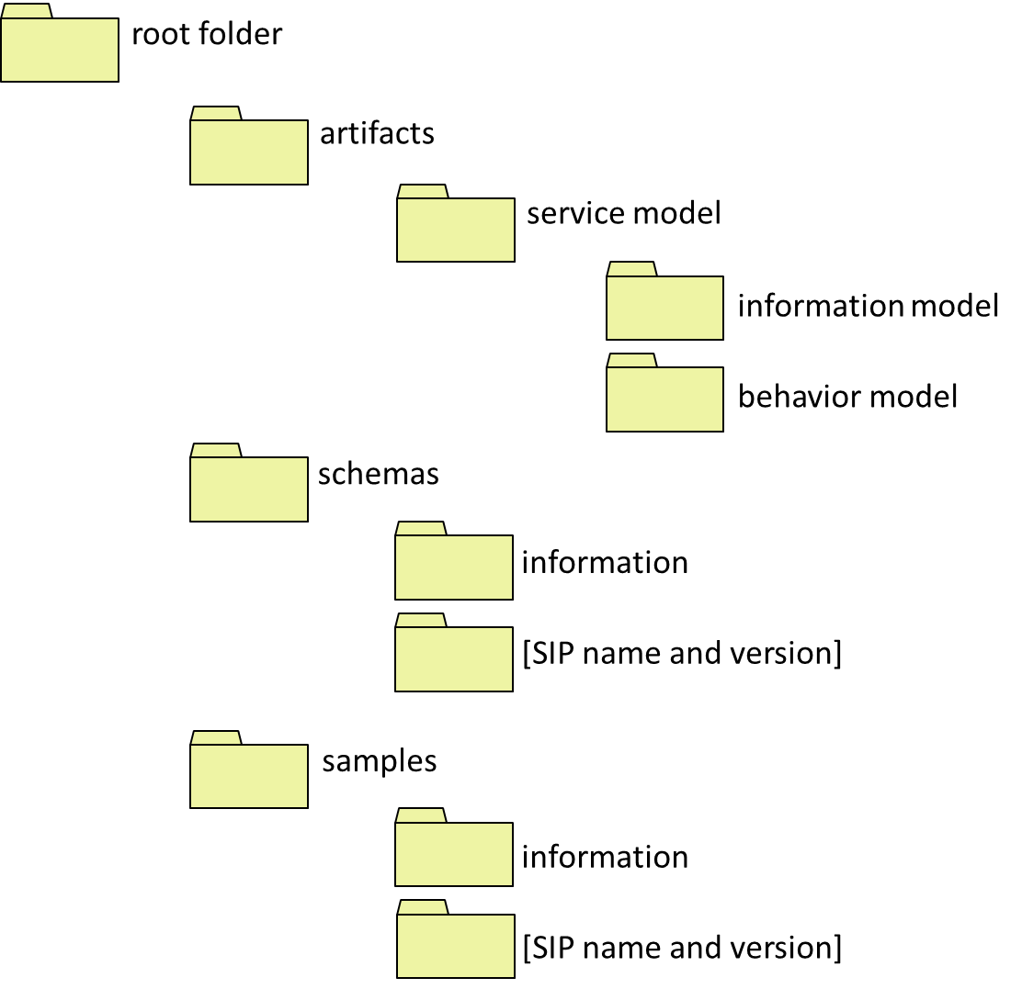
Figure 1 Mandatory SSP folder structure
A complete GRA SSP (Service Specification Package) comprises at least the following files:
- A Service Description, manifested in a Service Description Document (SDD). This is a human-readable file contained in the artifacts folder. For GRA-UML, XHTML format is generated.
- One or more Service Interface Descriptions, manifested in Service Interface Description Documents (SIDDs). Each Service Interface Description must conform to one or more Service Interaction Profiles (SIPs). SIDDs are human-readable files contained in the artifacts folder. For GRA-UML, XHTML format is generated.
- A Service Metadata file. This is called metadata.xml and contained in the root folder.
- A Service Catalog. This consists of two files, a machine-readable catalog.xml and a human-readable catalog.html, both contained in the root folder.
- A Service Specification Information Model, which must be a NIEM-conformant IEPD. This is packaged in a zip file or folder and contained in the artifacts/service model/information model folder.
- A Service Specification Behavior Model. In the case of GRA-UML, this is the Logical Service Model (see clause 7.3). It is contained in the artifacts/service model folder.
- Schemas. As per recent GRA guidance, Schemas not included in an IEPD that are used in the Service Specification are contained in the schemas/information folder. Web Service descriptions in WSDL format that are generated from the annotated GRA-UML model are contained in the schemas/[SIP name and version] folder, where the name of the folder corresponds to the SIP used to generate the WSDL.
Other optional files may be included and the folder structure may be extended according to rules specified by GRA. Such optional files and folders are not consumed or provisioned by GRA-UML and their description is omitted from this specification.

Two-Phase SSP Provisioning
GRA-UML has two potentially conflicting goals: to generate a fully GRA-conformant SSP, while providing flexibility in how SSPs are produced, what technologies are used and how these technologies are used. The reason for this flexibility as that GRA is essentially open ended with respect to the service interaction profiles (SIPs) used as well as what specific technologies are used within a SIP. In addition, SSP architects frequently have additional requirements or styles with respect to the generated documentation.
To resolve this dilemma the generation and provisioning of the final SSP is divided into two steps, called Phase-1 and Phase-2 as shown in Figure 2 below. Phase-1uses a standardized algorithm and is implemented in QVT; Phase-2 is customizable and is implemented using XSLT.
The GRA-UML services architect creates a model of the SSP containing two main aspects that separate concerns between the logical services and the GRA-specific requirements and metadata:
- The Logical Service Model - a platform-independent specification of the services to be automated by an implementation of the SSP, in terms of SOA constructs such as Actors, Use Cases, Components, Ports, Interfaces etc. It contains normal UML structures that are used to define services by applying simple conventions and a couple of GRA-specific stereotypes.
  - Note: this same UML model could be used and extended for purposes other than producing GRA specifications, such as producing implementations.
- The Annotation Model – a modeled specification of GRA-specific metadata, including technology and policy choices for the SSP, in cases where these choices cannot be inferred from the Logical Service Model by applying defaults.
Phase-1 uses a standardized algorithm to generate an intermediate format representation of the SSP. It uses the OMG’s QVT (Query/View/Transformation) to transform the GRA-UML model into a standardized XML-based format that contains all of the data required to generate the complete SSP. This intermediate format uses XMI (XML Metadata Interchange) corresponding to the OMG’s EMOF (Essential MOF) specification. XMI is an XML format with a schema that provides a convenient and standardized intermediate format for consumption by Phase-2.
Phase-2 uses an XSLT transformation template to generate the complete final SSP.
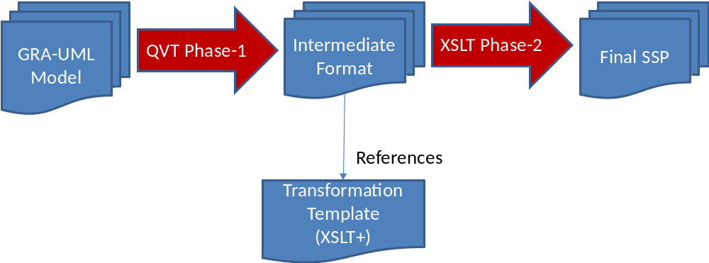
Figure 2 Two-phase provisioning
The envisaged workflow for a user of GRA-UML is as follows:
- User loads GRA-UML, which consists of the Logical Services Profile and the GRA Annotation Library, into a UML tool.
- User uses the Logical Services Profile to create the Logical Services platform-independent model – the PIM.
- User loads a starter annotation file which contains InstanceSpeifications classified by classes in the GRA Annotation Library (a starter file is provided as part of the specification).
- User edits and adds annotation elements and properties, and connects annotation elements to elements in the PIM using Realization and Usage dependencies.
- User invokes an action which causes the tool to, for each ServiceDescription:
- Generate the filled out intermediate format annotation instance file (annotations.xmi) and the other artifacts produced by stage one (catalog, etc)
- Invoke stage 2 to produce the final SSP artifacts and to place all artifacts correctly in the folder organization.

The Logical Service Profile
A UML Profile is a means to customize the general-purpose modeling language UML so that it can be used to create models that relate to a particular domain. A UML Profile has the following characteristics:
- It may define a subset of UML which is applicable to the intended domain.
- It may define a set of Stereotypes. These are labeled bundles of information which may be applied to particular kinds of UML element, carrying additional metadata relevant to the intended domain.
- It may define a library of domain-specific types for use within the model.
GRA-UML does all three of these. It defines:
- A subset of UML, used for modeling services at a logical, platform-independent level of abstraction.
- Two stereotypes, needed for distinguishing between service consumers and providers.
- The GRA Annotation Library, used to create elements that represent the detailed metadata required to provision SSPs. This library is described in clause 7.4 and specified in detail in clause 9.
This sub-clause describes the use of the first two of these constituents, which are together known as the Logical Services Profile.
Logical Service Models (LSMs) may contain any kind of UML element, but only those elements that are consumed by the transformations defined in this specification will influence the machine-generated outputs provisioned to the SSP. Logical Service Models use existing UML concepts in familiar ways and should be easily understood by typical UML users.
The Logical Service Profile is similar to, but considerably simpler than, OMG’s existing SoaML specification. It contains just two stereotypes called «Provider» and «Consumer» which are intended to be applied to UML Associations as shown in 7.3.2. No additional metadata is required to model the Logical Services Model using normal UML elements as shown in the following sections.

Actors
Actors are the business participants in the SSP’s subject community. They are typically people or organizations. Figure 3 shows Actors in an inheritance hierarchy.
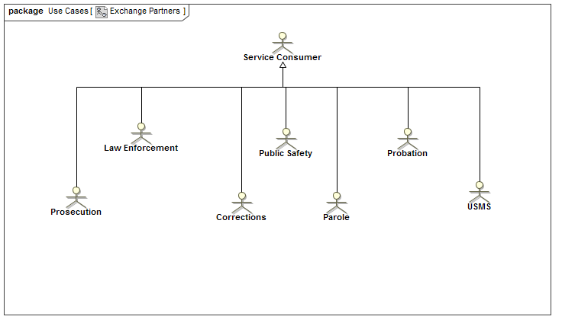
Figure 3 Actors

Use cases
The real-world effects of services are modeled as UseCases involving Actors. Each UseCase (oval) is a real-world effect and a business interaction. Each association between a UseCase and an Actor may be marked with a stereotype to indicate whether the Actor is a «Provider» or «Consumer» of the service. Figure 4 shows a simple example.
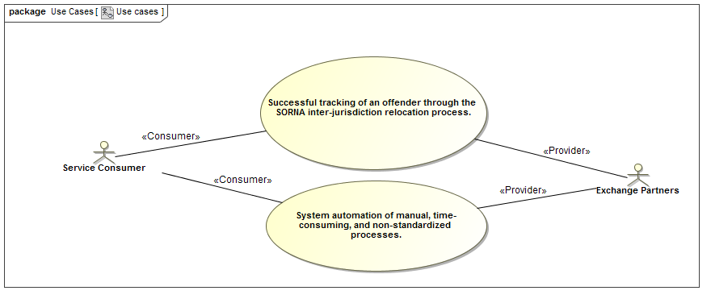
Figure 4 Use Cases

Interfaces
UML Interfaces define the operations and signal receptions that service providers implement to expose a service. The arguments of operations directly reference [NIEM-UML] message types as their content. Figure 5 shows a simple example.
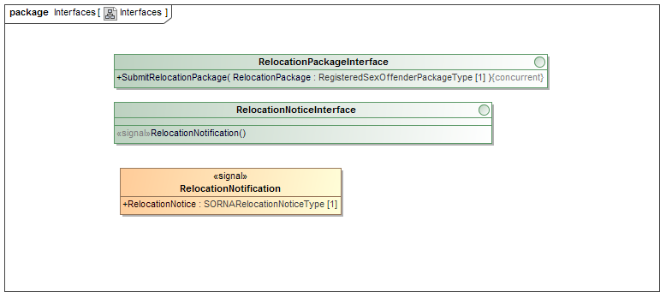
Figure 5 Interfaces

Components and ports
UML Components represent the service provided by an Actor. Each Component has a set of Ports that provide or use UML Interfaces. A Component may realize an Actor, to signify in the model that it represents a service provided by that Actor.
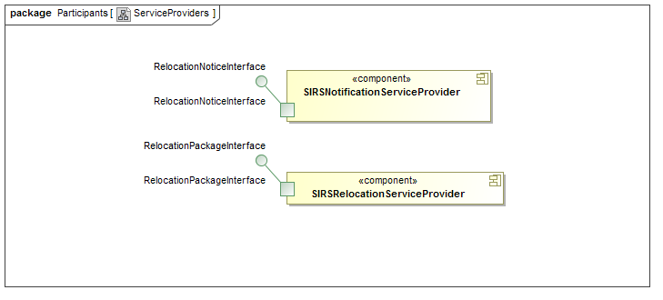
Figure 6 Components and Ports

Collaborations & Interactions
Collaborations are used to define the community for which the SSP is intended, providing a property for each Actor and service Component playing a role in that community.


Figure 7 Collaboration
The Collaboration that represents the community owns a set of Interactions that define the choreography of exchanges between the Actors to implement the UseCases. Figure 8 shows examples.
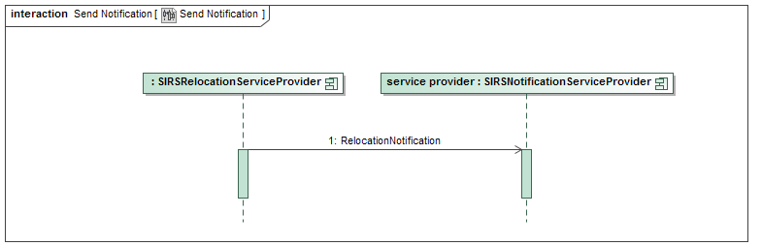
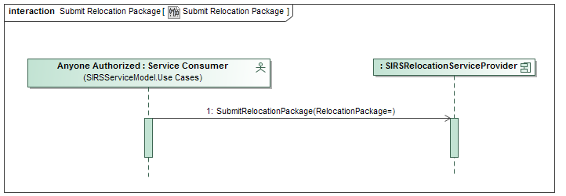
Figure 8 Interactions

The GRA Annotation Library

Overview
The GRA Annotation Library performs two roles in the overall workflow, and hence exists in two similar forms that differ in their details. The two forms are called the Annotations and the Intermediate Model. Both libraries contain the same UML classes and enumerations, with a few additional classes in the Intermediate Model. The Annotations are designed to simplify the modeling task by avoiding duplication of information and assuming that defaults are applied wherever possible. The Intermediate Model is designed to provide a convenient representation for consumption by Phase-2, which uses XSLT. So, for example, instances of the Intermediate Model are nested and avoid cross-references, whereas no such restriction applies to the Annotations.
The purpose of the Annotations is to provide the ingredients for the end user to model the GRA-specific metadata needed for generating the SSP. The end-user accomplishes this by creating UML InstanceSpecification elements that instantiate classes in the Annotations.
Note: For readability in describing the use of the annotation library, the word “instance” will be used to mean UML InstanceSpecification, unless this interpretation would cause confusion. See Figure 9 below for examples.
Having created instances, the user gives values to properties in those instances, links them together, and provides Realization dependencies between specific instances and elements in the Logical Service model, and Usage dependencies to the Information Model.
The purpose of the Intermediate Model is to act as a metamodel for the intermediate annotations.xmi format. The Phase-1 transformation consumes the end-user’s model created using the Annotations, and creates (in memory) additional InstanceSpecifications, links and property values that represent all of the annotations needed to generate the SSP. The resulting model is then serialized as XMI in OMG EMOF format, where each UML InstanceSpecification is serialized as an EMOF instance, and UML links and slots serialized as EMOF properties.
Although it would simplify this specification if these two libraries were identical, this would place an additional burden on the GRA-UML modeler to know about and ignore those elements that are only used in the Intermediate Model. The authors of GRA-UML consider this burden to be excessive, and hence have decided to keep the libraries separate, although for convenience they are documented together in Clause 9 of this specification.
The Annotation Library, in both of its forms, is specified in two packages: GRAAnnotationModel, containing platform-independent annotations, and GRA_WSDL, containing WSDL-specific annotations.
The pivotal class in the Annotations is ServiceDescription. The user creates an instance of this class to represent the overall service description which ultimately leads to the creation of an SSP. This ServiceDescription instance should be related to a Collaboration in the Logical Service Model by a UML Realization, signifying the community that the ServiceDescription relates to. It should also be related to the corresponding information model – one or more NIEM-conformant IEPDs – by means of UML Usages. Linked to the ServiceDescription is a set of instances that represent the metadata describing capabilities, requirements, exchange partners and so on; these instances, together with the properties of the ServiceDescription instance, are used to drive generation of the SDD documentation.
Accompanying the ServiceDescription instance are ServiceInterfaceSpecification instances that correspond to the Service Interfaces of the SPP. Each of these has properties and related instances that carry metadata to drive the generation of documentation. It also has related Service instances and a ServiceInteractionProfile instance that together drive the generation of WSDL schemas. As far as possible, default generation rules are applied, so that the user only needs to model exceptions from the default situation.

Example
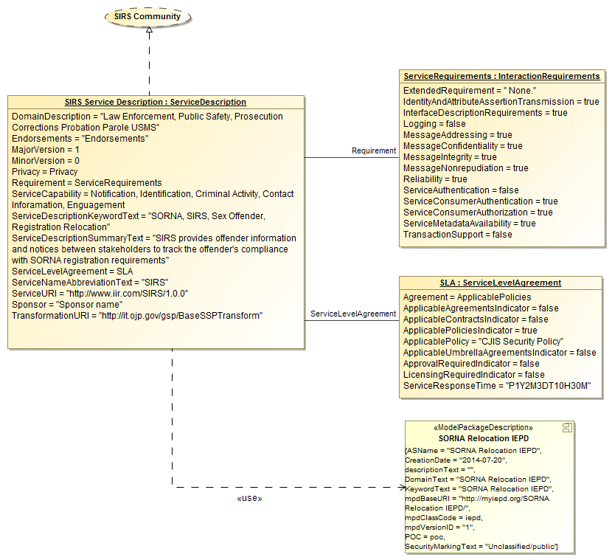
Figure 9 Example annotations
Figure 9 shows a partial example to illustrate some of these principles. A much more complete and comprehensive example appears in Annex A:
In Figure 9, SIRSServiceDescription is an instance of the class ServiceDescription, using the UML notation for InstanceSpecifications. This contains values for the properties defined in the class ServiceDescription, such as ServiceURI = “http://www.iir.com/SIRS/1.0.0”.
Some of the properties are also represented as links. In the example, the property ServiceLevelAgreement refers to the instance named SLA, an instance of the class ServiceLevelAgreement. The property Requirement is similarly shown.
Also shown on the diagram is a Realization from the SIRSServiceDescription instance to the Collaboration called SIRS Community. This is a part of the Logical Service Model which contains elements as described in clause 7.3. The Realization is notated as a dashed line with open triangular arrowhead.
Additionally a Usage dependency connects the SIRSServiceDescription instance to a ModelPackageDescription component from the Information Model. This component is constructed using the UML Profile for NIEM, which defines the «ModelPackageDescription» stereotype shown on the component.
Shown below is a fragment of the annotations.xmi file that corresponds to this example. The top-level element of this fragment corresponds to the SIRSServiceDescription instance. Within that element are attributes that correspond to many of the properties defined by the model. There is one attribute shown – serviceDescriptionURI – that does not appear in Figure 9; this value is derived by Phase-1 and only appears in the Intermediate Model. There is also a ModelReference element, also derived by Phase-1, resulting from the Realization between the SIRSServiceDescription instance and the SIRS Community collaboration. Such derivations are discussed in the next section.

<graa:ServiceDescription
xmlns:xmi=http://www.omg.org/spec/XMI/20110701
xmlns:xsi=http://www.w3.org/2001/XMLSchema-instance
xmlns:graa=http://ijis.org/GRA/Annotations
xmi:id="_0"
name="SIRS Service Description"
serviceUri=http://www.iir.com/SIRS/1.0.0
serviceNameAbbreviationText="SIRS"
serviceDescriptionSummaryText="SIRS provides offender information and notices between stakeholders to track the offender's compliance with SORNA registration requirements"
domainDescription="Law Enforcement, Public Safety, Prosecution Corrections Probation Parole USMS"
transformationUri=http://it.ojp.gov/gsp/BaseSSPTransform
majorVersion="1"
serviceDescriptionUri="artifacts/SIRS_SDD_v_1.0.0.docx">
<modelReference
xmi:id="_0.modelReference"
name="SIRS Community"
documentation="Stakeholders"
elementId="_17_0_5_1_7b3022e_1401746624193_446086_4974">
<model
xmi:id="_0.modelReference.model"
modelUri="platform:/resource/Examples/SIRS/SIRS_GRA_EXAMPLE/SIRS-Service.uml"
label="SIRS-Service"/>
</modelReference>
……
</ graa:ServiceDescription >

Derived properties
Many properties in the intermediate model are derived by Phase-1. For example, the property GRAServiceAnnotationBase::ModelReference is derived for any instance that has a Realization to an element in the Logical Service Model. The type of this property is the class ModelReference, which encapsulates a set of metadata used to identify and describe the realized logical service element. This property is derived by Phase-1 and emitted into the intermediate annotations.xmi for consumption by Phase-2. The Annotations contains neither this property nor the type ModelReference: all the modeler needs to do is create the correct Realization.
Another example involves Documentation properties. In the user’s model, text may be entered as documentation into a comment attached to the annotation instance: many UML tools distinguish the first comment of a model element through a special documentation field in the user interface. Alternatively the appropriate documentation might be found as a comment attached to a logical service element realized by the annotation instance. Either way, Phase-1 extracts the text from the appropriate comment and places it into a derived Documentation property for the Phase-2 XSLT to consume.
Table 2 specifies all of the properties that are derived by Phase-1, together with specifications of their derivations.

Defaults
To make the modeling process simpler and also to provide for flexibility in the technology and documentation artifacts produced, GRA-UML utilizes defaults at multiple levels. The following sections are intended to clarify the default mechanisms.
Some of these defaults are processed in Phase-1 whereas others are processed in Phase-2. Note that using the “template” mechanism of Phase-2, the Phase-2 defaults many be modified by the GRA-UML architect by providing an alternative template whereas the Phase-1 defaults are specified by the GRA-UML standard and are not modifiable.
Defaults fall into the following categories:
- Service hierarchy defaults, expanded in Phase-1
- Interaction Requirements defaults, expanded in Phase-2
- Property value defaults, provided in Phase-2

Service hierarchy defaults
A service specification and the typical WSDL artifacts produced from it follow a hierarchical pattern of:
- Service interface specification
  - Service
    - Port
      - Interface
        - Operation or signal
          - Parameter
            - Message
The output from Phase-1will have an annotation instance for every service, port, interface, operation, parameter and message defined by the logical service model. These will correspond to the
- Component realized by the service
- Ports on those service components
- Interfaces provided or used by those ports
- Operations and signals contained within those interfaces
- Parameters on the operations
- Messages that are the data types of the parameters
It is not necessary for the user to construct the corresponding hierarchy of annotations corresponding to the complete LSM: Phase-1 does that, and will provide default annotations for every element in the hierarchy. So in the simplest case the user only needs to specify the Service annotation, and everything else will be generated from the structure of the Logical Service Model.
For more control the user may override what Phase-1 does, by providing explicit annotations and defaults.
The user may create a corresponding explicit hierarchy of annotation instances: Port, Interface, Operation, Parameter, Message, where each annotation instance must connect via a Realization to its corresponding element in the LSM. In this case, Phase-1 will use the explicit annotations wherever they are provided.
Alternatively, the user may create default metadata for any of these elements. These are modeled using properties called PortDefault, InterfaceDefault, OperationDefault, ParameterDefault and MessageDefault, which can be set by the user on any higher level of the hierarchy – so for example an OperationDefault can be specified for a Port, but not vice-versa. If there is just one such default set on an element, and that default is not marked to realize anything, then that default metadata will be expanded for every corresponding subsidiary element in the intermediate file. A default may also be marked to realize a particular LSM element, in which case that default will be expanded as annotations for only that realized element - see 8.2.12.
None of these default properties appear in the intermediate annotations.xmi, since they would have all been expanded in Phase-1. The actions of Phase-1 also cause some differences in lower multiplicity bounds between the Intermediate Model and Annotations: where zero elements are required from the modeler, at least one element may be required in the intermediate form. All of these differences between the libraries are specified in Clause 9.

Example
The SIRS example has a default for “RelocationPackageInterface” as follows:
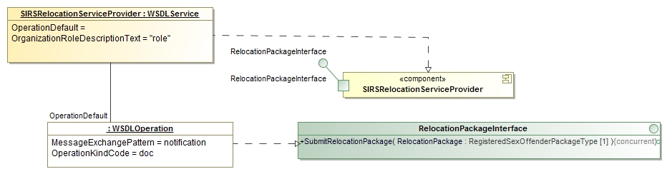
Figure 10 Example operation default
This shows an operation default that realizes the operation SubmitRelocationPackage. This specifies that the SubmitRelocationPackage operation will have a MessageExchangePattern of “notification” and and OperationKindCode of “doc”.
If there were no realization from this default, then it would apply to all operations within the hierarchical scope of SIRSRelocationServiceProvider.
The user could also have created an explicit hierarchy of WSDLPort, WSDLInterface and WSDLOperation annotations, explicitly realizing respectively the Port called RelocationPackageInterface, Interface called RelocationPackageInterface, and Operation called SubmitRelocationPackage. This would have the same effect.

Interaction requirements defaults
Interaction requirements specify the business requirements for a service interaction. Interaction requirements are specified using the following class:
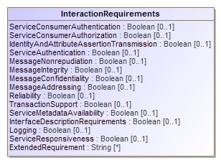
Figure 11 InteractionRequirements
Interaction requirements are meaningful through the full hierarchy of an SSP, starting with the “Service Description” and proceeding down the service hierarchy described above.
The InteractionRequirements specified at the level of the SSP are considered business requirements and are included in the GRA SDD document. These requirements also serve as a default for all the lower levels of the hierarchy, but any level of the hierarchy may override the more general requirements and specify the interaction requirements for that level.
If the interaction requirements are the same for the entire SSP there is only the need for the one InteractionRequirement annotation element. However it is common for specific ports, interfaces or operations to have more specific needs. To define these more specific needs a “Requirement” is linked to the more specific element and the requirement properties filled in.
Any property not specifically set to true or false in any InteractionRequirement element will acquire its value from a higher level, or if there is no such value, a default value for the property as specified by Table 3.
Phase-1 will only output the InteractionRequirements specifically provided by the model; the processing of these defaults is handled by Phase-2.

Property value defaults
There are many elements that are required by the WSDL or GRA specification that are typically filled in with “boilerplate” or other typical values. To simplify the model and also to provide flexibility as to the contents of this boilerplate, certain required properties may be omitted from the service specification. Phase-1 will fill in values that can be determined from the PIM. Phase-2 will then fill in any missing values with “boilerplate”. Any value that is specifically provided in the GRA model will take precedence over the boilerplate default. The GRA Phase-2 template contains a specific section for these defaults for easy modification [TBD].
Table 2 details the property values that will be calculated by Phase-1, if no value is provided by the modeler. Table 3 details the property values that will be used by Phase-2, if no value is provided by Phase-1. The end-result should be a valid GRA SSP with all mandatory values included.

Example
The GRA specification requires a “Security” section. Many SSPs use a standard text of the form:
The service implementation must follow the Service Interface Description Document (SIDD) to meet the Security Requirements.
The service must adhere to the rules of the CJIS Security Policies regarding the Advanced Encryption Standard (AES) level of encryption.
If the “Security” property of a ServiceDescription has no value provided, Phase-2 will insert the above text.

Compositions
XSLT transformations work best on hierarchically-structured documents, and Phase-2 is an XSLT that consumes the output of Phase-1. So the intermediate form is designed to be hierarchical, and this is represented in the Intermediate Model by numerous compositions. From the modeler’s perspective, however, it may be inconvenient to structure the annotations hierarchically: the same annotation may be shared between several elements, and this is most simply represented simply by linking them together. So in the Annotations there are no compositions; one of the tasks of Phase-1 is to duplicate annotation elements shared in the user’s model so that they are hierarchically represented in the intermediate model.
An example of this approach is the property GRAServiceAnnotationBase::InteractionRequirements. This allows the attaching of an instance of InteractionRequirements at any level of the model from the complete ServiceDescription down to the individual Message. This instance provides a bundle of metadata specifying interaction requirements for the element to which it is attached – see the description in 7.4.5, above. The user might share a single instance of InteractionRequirements amongst, say, a set of Operations; Phase-1 processing would replicate that instance so that a copy is hierarchically contained with the metadata for all of those operations in the intermediate annotations.xmi.
Clause 9 specifies where these compositions differ between the libraries.

GRA-UML Logical Services Profile

UML subset
GRA-UML Logical Service Models are normal UML models. Any UML construct can be used within a GRA LSM. However, only certain elements within the LSM are consumed by the SSP provisioning process. The following section documents those elements. Other elements may be used for documentation purposes, or as input to other provisioning processes outside the scope of this specification. The complete Logical Service Model is itself part of the provisioned SSP, appearing in the artifacts/service model folder.

Logical service classes
This section specifies the UML classes whose instances affect Phase-1 of SSP provisioning. These are classes from the complete merged L3 version of UML 2.4.1, in which each is fully identified by their name, so for example the xmi definition of Actor may be found at http://www.omg.org/spec/UML/20110701/UML.xmi#Actor.
Elements in the model that do not have an effect documented here or in NIEM-UML are ignored by Phase-1.

Actor
A UML Actor represents a participant in the SSP subject community. Actors are used by Phase-1 to populate the property ServiceDescription::ExchangePartner. Actors may be directly realized by Participants in the annotation model, or may be contained in realized Packages (see Error: Reference source not found). AlsowWhere an Actor plays a role in a Collaboration realized by the ServiceDescription, a corresponding ExchangePartner is generated, if it is not already present.

Association
A UML Association between an Actor and a UseCase stereotyped as «Provider» or «Consumer» (see 8.3) specifies whether the ExchangePartner represented by the Actor is a provider or consumer of the RealWorldEffect represented by the UseCase. Such an Association is used by Phase-1 to populate the annotation properties UseCase::Provider and UseCase::Consumer.

Collaboration
A UML Collaboration represents the community involved in the SSP. It must be realized by the ServiceDescription that represents the SSP. Phase-1 generates a ModelReference from this realization, and ServiceInteractions that correspond to the Interactions owned by the Collaboration. Where an Actor plays a role in a Collaboration realized by the ServiceDescription, a corresponding ExchangePartner is generated, if it is not already present.

Component
A UML Component represents a Service.
A Component may realize an Actor, signifying that it represents a Service provided by the Participant represented by that Actor. Such a Realization is used by Phase-1 to populate the property Service::ServiceProvider.
A Component may be realized by a Service annotation, providing the foundation for a service interface description. Each service interface description must have a Service realizing a Component. Phase-1 uses this Realization to generate the service hierarchy (see 7.4.4).

Interaction
A UML Interaction represents a service interaction. Each Interaction owned by the top-level Collaboration will cause the generation of a ServiceInteraction whose Participants realize Actors that participate in the Interaction.

Interface
A UML Interface represents an interface on the port that provides the interface. Phase-1 uses Port::provided to generate the service hierarchy (see 7.4.4).

Operation
A UML Operation represents a synchronous operation on the interface that owns it. Phase-1 uses Interface::ownedOperation to generate the service hierarchy (see 7.4.4), and for each Operation generates an operation annotation with IsAsynchronous = false. If the Operation has any raisedExceptions, these cause the generation of parameter annotations with Use = ParameterUse::exception.

Package
A UML Package may be used to collect together Actors or UseCases. Where Actors are contained by Packages, those Packages may be realized by Participants in the annotation model, in which case Phase-1 generates an ExchangePartner for each Actor contained in the Package. Where UseCases are contained by Packages, those Packages may be realized by UseCases in the annotation model, in which case Phase-1 generates a RealWorldEffect for each UseCase contained in the Package.

Parameter
A UML Parameter represents a parameter to the operation that owns it. Phase-1 uses Operation::ownedParameter and Reception::ownedParameter (or, equivalently, Reception::signal.ownedAttribute) to generate the service hierarchy (see 7.4.4), and for each Parameter generates a parameter annotation. If the Operation or Reception has any raisedExceptions, these cause the generation of parameter annotations with Use = ParameterUse::exception, and whose message refers to the raisedException type.

Port
A UML Port represents a port on the Service represented by the Component that owns the Port. Phase-1 uses Component::ownedPort to generate the service hierarchy (see 7.4.4).

Reception
A UML Operation represents an aSynchronous operation on the interface that owns it. Phase-1 uses Interface::ownedReception to generate the service hierarchy (see 7.4.4), and for each Reception generates an operation annotation with IsAsynchronous = true. If the Reception has any raisedExceptions, these cause the generation of parameter annotations with Use = ParameterUse::exception.

Realization
UML Realizations are primarily used to relate annotations to the Logical Service Model elements that they annotate. The following table specifies which Realizations are processed by Phase-1. A name preceded by a colon (e.g. :Participant) signifies that the Realization is connected to an InstanceSpecification classified by the named annotation type. A name without a colon (e.g. Actor) signifies that the Realization is connected to a UML model element of the named type. These definitions apply equally to subtypes, e.g. a :WSDLPort annotation follows the same rules as a :Port annotation.
Any Realizations not in this table have no effect. For any Realizations in the table where the Phase-1 result is conditional, under other conditions the Realization has no effect.

Table 1 Realizations
Source | Target | Phase-1 result
:ServiceDescription | Collaboration | A ServiceDescription instance is generated containing ServiceInteractions for every Interaction owned by the Collaboration, and an exchange partner for every Actor that plays a role in any of those Interactions.
:Participant | Actor | A single Participant instance is generated corresponding to the Actor.
:Participant | Package | A Participant instance is generated corresponding to every Actor in the Package.
:UseCase | UseCase | A single UseCase instance is generated representing the real world effect.
:UseCase | Package | A UseCase instance is generated corresponding to every UseCase in the Package.
:Service | Component | A Service instance is generated whose hierarchical contents are systematically derived from the hierarchical contents of the Component.
Component | Actor | A :Service that realizes the Component shall contain a serviceProvider element corresponding to the Actor.
:Port | Port | A Port instance generated in the service hierarchy corresponding to the target Port is explicitly specified by the source :Port annotation.
:Interface | Interface | A Interface instance generated in the service hierarchy corresponding to the target Interface is explicitly specified by the source :Interface annotation.
:Operation | Operation | An Operation instance generated in the service hierarchy corresponding to the target Operation is explicitly specified by the source :Operation annotation.
:Operation | Reception | An Operation instance generated in the service hierarchy corresponding to the target Reception is explicitly specified by the source :Operation annotation.
:Parameter | Parameter | A Parameter instance generated in the service hierarchy corresponding to the target Parameter is explicitly specified by the source :Parameter annotation.
:Port | Component | If the source :Port is a PortDefault for Sis:ServiceInterfaceSpecification and the target Component is realized by a Service owned by Sis, then within the scope of that Service, Port instances generated in the service hierarchy shall contain the properties specified by the source :Port annotation.
:Interface | Component | If the source :Interface is an InterfaceDefault for Sis:ServiceInterfaceSpecification and the target Component is realized by a Service owned by Sis, then within the scope of that Service, Interface instances generated in the service hierarchy shall contain the properties specified by the source :Interface annotation.
:Interface | Port | If the source :Interface is an InterfaceDefault for Sis:ServiceInterfaceSpecification and the target Port is owned by a Component realized by a Service owned by Sis, then within the scope of that Port, Interface instances generated in the service hierarchy shall contain the properties specified by the source :Interface annotation.  If the source :Interface is an InterfaceDefault for S:Service and the target Port is owned by a Component that is realized by S, then within the scope of that Port, Interface instances generated in the service hierarchy shall contain the properties specified by the source :Interface annotation.
:Operation | Component | If the source :Operation is an OperationDefault for Sis:ServiceInterfaceSpecification and the target Component is realized by a Service owned by Sis, then within the scope of that Service, Operation instances generated in the service hierarchy shall contain the properties specified by the source :Operation annotation.
:Operation | Port | If the source :Operation is an OperationDefault for Sis:ServiceInterfaceSpecification and the target Port is owned by a Component realized by a Service owned by Sis, then within the scope of that Port, Operation instances generated in the service hierarchy shall contain the properties specified by the source :Operation annotation.  If the source :Operation is an OperationDefault for S:Service and the target Port is owned by a Component realized by S, then within the scope of that Port, Operation instances generated in the service hierarchy shall contain the properties specified by the source :Operation annotation.
:Operation | Interface | If the source :Operation is an OperationDefault for Sis:ServiceInterfaceSpecification and the target Interface is owned by a Port owned by a Component realized by a Service owned by Sis, then within the scope of that Interface, Operation instances generated in the service hierarchy shall contain the properties specified by the source :Operation annotation.  If the source :Operation is an OperationDefault for S:Service and the target Interface is provided by a Port owned by a Component realized by S, then within the scope of that Interface, Operation instances generated in the service hierarchy shall contain the properties specified by the source :Operation annotation.  If the source :Operation is an OperationDefault for P:Port and the target Interface is provided by P, then within the scope of that Interface, Operation instances generated in the service hierarchy shall contain the properties specified by the source :Operation annotation.
:Parameter | Component | If the source :Parameter is a ParameterDefault for Sis:ServiceInterfaceSpecification and the target Component is realized by a Service owned by Sis, then within the scope of that Service, Parameter instances generated in the service hierarchy shall contain the properties specified by the source :Parameter annotation.
:Parameter | Port | If the source :Parameter is a ParameterDefault for Sis:ServiceInterfaceSpecification and the target Port is owned by a Component realized by a Service owned by Sis, then within the scope of that Port, Parametert instances generated in the service hierarchy shall contain the properties specified by the source :Parameter annotation.  If the source :Parameter is a ParameterDefault for S:Service and the target Port is owned by a Component realized by S, then within the scope of that Port, Parameter instances generated in the service hierarchy shall contain the properties specified by the source :Parameter annotation.
:Parameter | Interface | If the source :Parameter is a ParameterDefault for Sis:ServiceInterfaceSpecification and the target Interface is provided by a Port owned by a Component realized by a Service owned by Sis, then within the scope of that Interface, Parameter instances generated in the service hierarchy shall contain the properties specified by the source :Parameter annotation.  If the source :Parameter is a ParameterDefault for S:Service and the target Interface is provided by a Port owned by a Component realized by S, then within the scope of that Interface, Parameter instances generated in the service hierarchy shall contain the properties specified by the source :Parameter annotation.  If the source :Parameter is a ParameterDefault for P:Port and the target Interface is provided by P, then within the scope of that Interface, Parameter instances generated in the service hierarchy shall contain the properties specified by the source :Parameter annotation.
:Parameter | Operation | If the source :Parameter is a ParameterDefault for Sis:ServiceInterfaceSpecification and the target Operation is owned by an Interface provided by a Port owned by a Component realized by a Service owned by Sis, then within the scope of that Operation, Parameter instances generated in the service hierarchy shall contain the properties specified by the source :Parameter annotation.  If the source :Parameter is a ParameterDefault for S:Service and the target Operation is owned by an Interface provided by a Port owned by a Component realized by S, then within the scope of that Operation, Parameter instances generated in the service hierarchy shall contain the properties specified by the source :Parameter annotation.  If the source :Parameter is a ParameterDefault for P:Port and the target Operation is owned by an Interface provided by P, then within the scope of that Operation, Parameter instances generated in the service hierarchy shall contain the properties specified by the source :Parameter annotation.  If the source :Parameter is a ParameterDefault for I:Interface and the target Operation is owned by I, then within the scope of that Operation, Parameter instances generated in the service hierarchy shall contain the properties specified by the source :Parameter annotation.
:Parameter | Reception | If the source :Parameter is a ParameterDefault for Sis:ServiceInterfaceSpecification and the target Reception is owned by an Interface provided by a Port owned by a Component realized by a Service owned by Sis, then within the scope of that Reception, Parameter instances generated in the service hierarchy shall contain the properties specified by the source :Parameter annotation.  If the source :Parameter is a ParameterDefault for S:Service and the target Reception is owned by an Interface provided by a Port owned by a Component realized by S, then within the scope of that Reception, Parameter instances generated in the service hierarchy shall contain the properties specified by the source :Parameter annotation.  If the source :Parameter is a ParameterDefault for P:Port and the target Reception is owned by an Interface provided by P, then within the scope of that Reception, Parameter instances generated in the service hierarchy shall contain the properties specified by the source :Parameter annotation.  If the source :Parameter is a ParameterDefault for I:Interface and the target Reception is owned by I, then within the scope of that Reception, Parameter instances generated in the service hierarchy shall contain the properties specified by the source :Parameter annotation.
:Message | Type | If the source :Message is a MessageDefault for an element E, then within the scope of E, Message instances generated in the service hierarchy that correspond to the target type shall contain the properties specified by the source :Message annotation.

Signal
A UML Signal is associated with each Reception that represents an asynchronous operation. The attributes of the Signal match the parameters of the Reception according to UML rules.

Type
UML Types represent the information model according to the principles defined by NIEM-UML.

Usage
A UML Usage is used to relate a ServiceDescription to each IEPD that it uses. Each Usage is used by Phase-1 to generate an IEPDReference in the ServiceDescription.

UseCase
A UML UseCase represents a “real world effect” – the user’s understanding of a service. UseCases are used by Phase-1 to populate the property ServiceDescription::RealWorldEffect. UseCase annotations may be directly realized by UML UseCases, or may be contained in realized Packages (see Error: Reference source not found).

Stereotypes

«Provider»
The Provider stereotype may be applied to a UML Association between an Actor and UseCase. It signifies that the ExchangePartner represented by the Actor is a provider of the RealWorldEffect represented by the UseCase.

«Consumer»
The Consumer stereotype may be applied to a UML Association between an Actor and UseCase. It signifies that the ExchangePartner represented by the Actor is a consumer of the RealWorldEffect represented by the UseCase.

GRA Annotations

Package GRAUML::GRAAnnotationModel
<Generated from model>

Package GRAUML::GRA_WSDL
<Generated from model>

Phase-1 Derived Properties
Table 2 below summarizes all of the properties in the intermediate model (serialized as annotations.xmi) whose values are calculated by Phase-1. Where the derivation uses the term “instance” it refers to the InstanceSpecification in the annotation model. Where the derivation uses the term “documentation” it means that the related UML model element should have exactly one ownedComment, and the documentation is the contents of the body of that comment.

Table 2 Phase-1 Derived Properties
Class | Name | Type | Phase 1 Derivation
Agreement | Documentation | String | Instance documentation
Description | Documentation | String | Instance documentation
GRAServiceAnnotationBase | Documentation | String | Realized element's documentation or instance documentation
GRAServiceAnnotationBase | ModelReference | ModelReference | Realized element
GRAServiceAnnotationBase | Name | String | Instance name or realized element's name
IEPDReference | IEPDURL | String | Usage target
IEPDReference | Name | String | Usage target's name
Interface | Operation | Operation | Either explicitly declared or derived from the Operations/Receptions in the service hierarchy.
Message | Prefix | String | Derived from the defaultPrefix tag on the NIEM information model containing the type relating to this Message.
Message | ElementPrefix | String | Derived from the defaultPrefix tag on the NIEM information model containing the element whose type is the message part type.
Message | ElementModelReference | ModelReference | The ModelReference associated with a message part element, derived from the NIEM type by selecting a NIEM property (i.e., xml element) whose type is the message part type.
Message | ElementName | String | The name of the element whose type is the message part type.
Model | Label | String | Created from realization. The name of the realization target's model.
Model | ModelURI | String | Created from realization. The URI of the realization target's model resource.
ModelReference | DiagramLink | String | Created from realization. URIs of diagrams associated with the realized element.
ModelReference | Documentation | String | Created from realization. Documentation of the realized element.
ModelReference | ElementID | String | Created from realization. Id of the realized element.
ModelReference | Model | Model | Created from realization. Model containing the realized element.
ModelReference | Name | String | Created from realization. Name of the realized element.
Operation | ActionName | String | Realized element's name.
Operation | ActionPurpose | String | Realized element's documentation.
Operation | IsAsynchronous | Boolean | True if realized element is Reception; false if realized element is Operation.
Operation | Parameter | Parameter | Either explicitly declared or derived from the parameters of Operations/Receptions in the service hierarchy.
Parameter | Message | Message | Either explicitly declared or derived from the parameter's type.
Parameter | Use | ParameterUse | Derived from parameter’s direction.
Participant | Generalization | Participant | Derived from Actor generalization.
Port | Interface | Interface | Either explicitly declared or derived from the parameters of Operations/Receptions in the service hierarchy.
SchemaReference | Namespace | String | Namepace of schema. Derived from those parts of the information model that are referenced from the service interface.
SchemaReference | Prefix | String | Prefix used to reference Schema Namespace. Derived from those parts of the information model that are referenced from the service interface.
SchemaReference | SchemaLocation | String | URI of Schema, relative to SSP Catalog. Derived from those parts of the information model that are referenced from the service interface.
SecurityClassification | Name | String | Instance name.
Service | Port | Port | Either explicitly declared or derived from Ports on the realized Component.
Service | ServiceProvider | Participant | Derived from a Realization between the service's realized Component and the participant's realized Actor.
ServiceCapability | Documentation | String | Instance documentation.
ServiceDescription | Exchange  Partner | Participant | Actors defined in service interactions in realized Collaboration, or where an actor or package containing actors is explicitly realized by an ExchangePartner annotation instance.
ServiceDescription | IEPDReference | IEPDReference | Derived from usage to IEPD.
ServiceDescription | RealWorld  Effect | UseCase | If the modeled real world effect realizes a package, then Phase 1 expands it to give a real world effect for every use case in that package.
ServiceDescription | RevisionVersion | Integer | If nothing is modeled, 1 is inserted.
ServiceDescription | Service  DescriptionURI | String | artifacts/[Service Abbreviation]_SDD_v_[major].[minor].[revision]
ServiceDescription | Service  Interaction | ServiceInteraction | Derived from Interactions owned by the realized Collaboration.
ServiceDescription | Transformation  URI | String | http://it.ojp.gov/gsp/BaseSSPTransform
ServiceInteraction | Participant | Participant | Derived from the Actors that play a role in the Interaction realized by the ServiceInteraction.
ServiceInterfaceSpecification | Prefix | String | Derived from (the same as) ServiceInterfaceNameAbbeviationText
ServiceInterfaceSpecification | Schema  Reference | SchemaReference | Derived from those parts of the information model that are referenced from the service interface.
ServiceInterfaceSpecification | ServiceInterface  DescriptionURI | String | artifacts/[Service Abbreviation]_SIDD_[Service Interface Abbreviation] v_[major].[minor].[revision]
ServiceInterfaceSpecification | URIAddress | String | Derived

Phase-2 Default Property Values
Table 3 below summarizes values that should be assumed by Phase-2 if no values are set in the intermediate file by Phase-1.

Table 3 Phase-2 Default Property Values
Class | Name | Type | Default value
Agreement | Automated  Agreement  Indicator | Boolean | FALSE
GRAServiceAnnotationBase | Requirement | Interaction  Requirements | Default requirements
InteractionRequirements | IdentityAnd  Attribute  Assertion  Transmission | Boolean | FALSE
InteractionRequirements | Interface  Description  Requirements | Boolean | TRUE
InteractionRequirements | Logging | Boolean | FALSE
InteractionRequirements | Message  Addressing | Boolean | TRUE
InteractionRequirements | Message  Confidentiality | Boolean | FALSE
InteractionRequirements | Message  Integrity | Boolean | FALSE
InteractionRequirements | Message  Nonrepudiation | Boolean | FALSE
InteractionRequirements | Reliability | Boolean | FALSE
InteractionRequirements | Service  Authentication | Boolean | FALSE
InteractionRequirements | Service  Consumer  Authentication | Boolean | FALSE
InteractionRequirements | Service  Consumer  Authorization | Boolean | FALSE
InteractionRequirements | Service  Metadata  Availability | Boolean | FALSE
InteractionRequirements | Service  Responsiveness | Boolean | FALSE
InteractionRequirements | Transaction  Support | Boolean | FALSE
Port | AddressURI | String | ServiceInterfaceURI+"/"+"Name"
ServiceDescription | Additional  Information | Description | "N/A"
ServiceDescription | CreationDate | String | [today]
ServiceDescription | DataProvenance | Description | “Provenance is defined as the agency, office, or person of origin of records, i.e., the entity that created, received, or accumulated and used the records in the conduct of their business activities. All applicable provenance information or restrictions are provided below. Also, additional artifacts related to this sections content can be provided in the service model folders of the service package. [Service Abbreviation] SSP [Service Version]\artifacts\service model\information model”
ServiceDescription | Domain  Description | String | "N/A"
ServiceDescription | Execution  Context | Description | “Service descriptions should include all information pertinent to the production or consumption of the service, including expected infrastructure functions and other dependencies. No information directly pertaining to implementation platform or technology should be included in the service description.”
ServiceDescription | LifecycleStatus | String | Boilerplate TBD
ServiceDescription | Other  Requirement | Description | "N/A"
ServiceDescription | Privacy | Description | “The MOUs between participating entities will further define specific privacy requirements. Global has developed a document, “Implementing Privacy Policy in Justice Information Sharing: A Technical Framework” This document is intended to provide guidelines for supporting the electronic expression of privacy policy and how to convert privacy policy so that it is understandable to computers and software.”
ServiceDescription | Security | Description | “The service must adhere to the rules of the CJIS Security Policies regarding the Advanced Encryption Standard (AES) level of encryption. The use of Virtual Private Networks (VPNs) or Secure Sockets Layer (SSL) for transport-level security in addition to these requirements is optional.”
ServiceDescription | Service  Assumption | Description | “N/A”
ServiceDescription | Service  Dependency | Service  Identification | "N/A"
ServiceDescription | ServiceLevel  Agreement | ServiceLevel  Agreement | None
ServiceDescription | ServiceSecurityClassification | Security  Classification | “The highest level of security classification for the information exchanged by this service is Sensitive but Unclassified (SBU). As a result the service can be assigned a security classification of SBU.”
ServiceInterfaceSpecification | Message  Definition  Mechanism | Description | “The service will comply with the message definition mechanisms identified in the GRA Reliable Secure Web Services Service Interaction Profile, Version 1.2 (GRA RS WS-SIP 1.2).”
ServiceInterfaceSpecification | Security  Description  Text | String | “The service must adhere to the rules of the CJIS Security Policies regarding the Advanced Encryption Standard (AES) level of encryption. The use of Virtual Private Networks (VPNs) or Secure Sockets Layer (SSL) for transport-level security in addition to these requirements is optional.”
ServiceInterfaceSpecification | Security  Implemented  Indicator | Boolean | TRUE if the technology implements security
ServiceInterfaceSpecification | ServiceTesting | Description | “The service validation and testing will leverage the Springboard specification to validate the interoperable aspects of the service interface specification in order to assert that a participating system conforms to the underlying specification. The conformance specification and the associated test cases define a series of tests designed to exercise each interoperability aspect of the specification at least once. The validation testing is not intended to address functional aspects of the systems/services nor is the test suite designed to verify the robustness or performance of the interface software.”
ServiceLevelAgreement | Applicable  Agreements  Indicator | Boolean | TRUE if there are agreements
ServiceLevelAgreement | Applicable  Contracts  Indicator | Boolean | TRUE if contracts specified
ServiceLevelAgreement | Applicable  Policies  Indicator | Boolean | TRUE if policies specified
ServiceLevelAgreement | Applicable  Umbrella  Agreements  Indicator | Boolean | TRUE if umbrellas specified
ServiceLevelAgreement | Approval  Required  Indicator | Boolean | FALSE
ServiceLevelAgreement | Licensing  Required  Indicator | Boolean | TRUE if licensing specified
WSDLInterface | BindingCode | BindingType | soap12
WSDLMessage | Encoding | String | Document / Literal
WSDLMessage | Message  LocationCode | Message  Location | Body
WSDLMessage | SoapAction | String | * Derived
WSDLOperation | Operation  KindCode | OperationKind | doc
WSDLParameter | MimeType | String | text/xml

GRA-UML Transformations
This clause will be completed in the revised submission.

SSP workflow and structure
Explain how all the transformations fit together in an overall workflow and resulting folder structure.

Catalog.xml
Specify catalog schema and metamodel. Note: metamodel includes tool-specific extensions annotating the metamodel to enable XML document generation and representation of the XML type library.
Specify QVT. Describe the action of the QVT in a readable way (Tom?)

Metadata.xml
Specify metadata schema and metamodel. Note: metamodel includes tool-specific extensions annotating the metamodel to enable XML document generation and representation of the XML type library.
Specify QVT. Describe the action of the QVT in a readable way (Tom?)

Annotations.xmi
Explain the rules for populating the annotation model from the PIM + the modeled annotations. (Tom)
Explain how XMI is generated from the annotation model as an EMOF instance.
Specify QVT. Describe the action of the QVT in a readable way (Tom?)

SDD
Using XSLT to generate SDD XHTML from the annotations.xmi. Describe the action of the XSLT in a readable way.

SIDD
Using XSLT to generate SIDD XHTML from the annotations.xmi. Describe the action of the XSLT in a readable way.

WSDL
Using XSLT to generate WSDL from the annotations.xmi. Describe the action of the XSLT in a readable way.

GRA-UML Example

(informative)
This annex contains a simple example to illustrate the concepts. The example describes a Pet Adoption Center: a fictitious agency whose business is the adoption of (presumably unwanted) pets. This is an extension of the example elaborated in the NIEM-UML profile [NIEM-UML], emphasizing that the information transferred by GRA services is specified using NIEM. The aim is to generate a Service Specification Package (SSP) that defines the services provided and consumed in the pet adoption community.
We start with the Platform Independent Model (PIM). This is a UML model, built using the Logical Service Profile under GRA-UML conventions, which describes services provided by the Pet Adoption Centre.
The PIM contains Actors, which depict the entities that interact when services are offered or consumed. Actors are often people or classes of people, organizations or classes of organizations, or even machines or classes of machines. In this example there are two Actors: the PetAdoptionCenter, and Anyone.
In the PIM, a UseCase represents the user’s view of a service, which is known in GRA as the “real world effect”. In this example there is one service: “Provide information on a particular pet adoption based on the ID of the adopting individual”. The Actors and the UseCase are shown together on a single diagram in Figure 12, which also shows by associations stereotyped «Provider» and «Consumer» that the PetAdoptionCenter provides this service, and Anyone may consume it. These Actors and UseCase are contained in a Package called Use Cases: this fact will be important later.
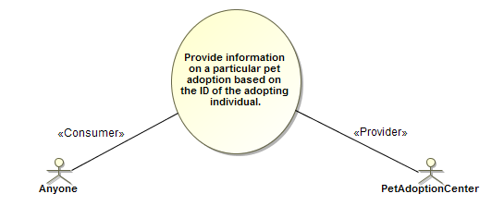
Figure 12 Pet Adoption Actors and UseCase
Interfaces in the PIM define the operations and signal receptions that service providers implement to offer a service. For the PetAdoptionCenter there is a single Interface, shown in Figure 13, with a single Operation.
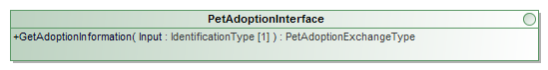
Figure 13 PetAdoptionInterface
The argument and result of the operation directly reference [NIEM-UML] message types IdentificationType and PetAdoptionExchangeType. IdentificationType comes from PetAdoptionNIEMCoreSubset, and PetAdoptionExchangeType from PetAdoptionExtension, both of which are InformationModels in the NIEM IEPD (Information Exchange Package Documentation) depicted in Figure 14, which is constructed according to the rules and conventions of NIEM-UML. Full explanation of this IEPD can be found in the [NIEM-UML] specification.
The GetAdoptionInformation operation also has a raisedException of PetAdoptionExtension::Exception, which is not shown on the diagram, but flows through the SSP provisioning process into the eventual WSDL.
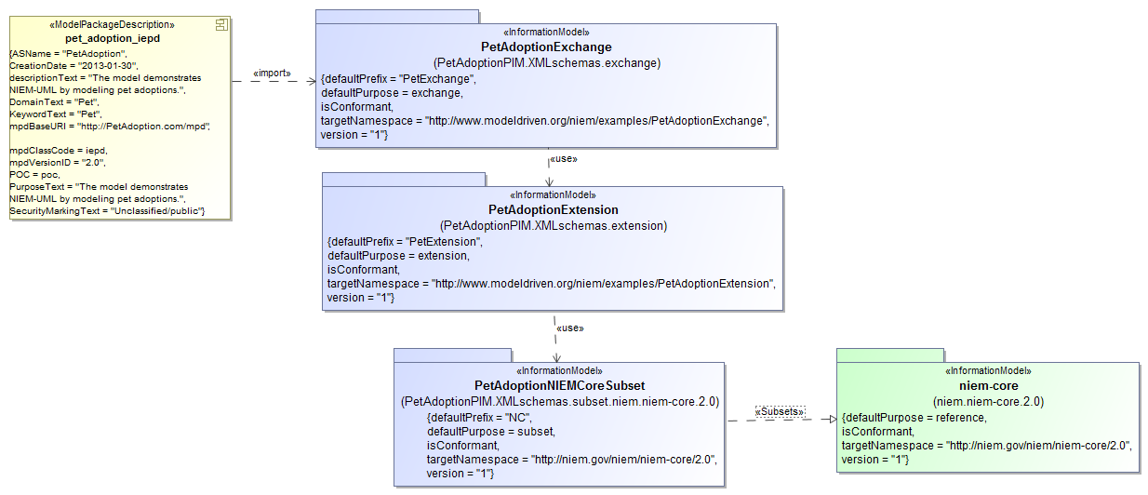
Figure 14 Pet Adoption IEPD
In a GRA-UML PIM, Interfaces are provided by Ports on Components. In this example there is a single Component with a single Port – called ServicePort - which provides the PetAdoptionInterface, as shown in Figure 15.
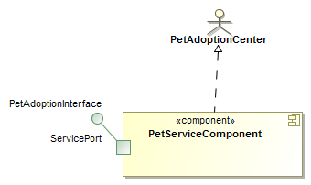
Figure 15 PetServiceComponent
Figure 15 also shows PetServiceComponent realizing the PetAdoptionCenter actor: the dashed arrow with the open triangle arrowhead signifies a UML Realization. This means that the Component represents a service offered by that Actor.
The PetServiceComponent realizing the PetAdoptionCenter may also be shown on the UseCase diagram, as illustrated by Figure 16.
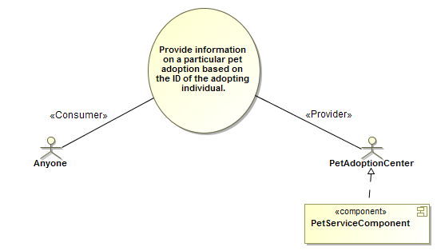
Figure 16 UseCase diagram showing Component realization
The central element of the PIM is a single UML Collaboration that represents the community involved in the provision and consumption of pet adoption services, and pulls together the participants by representing them as roles in the Collaboration.
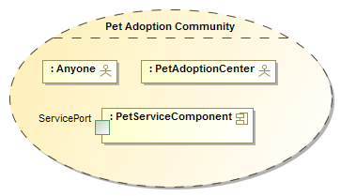
Figure 17 Pet Adoption Community Collaboration
The final aspect of the Pet Adoption PIM is shown in the Interaction in Figure 18, in which Anyone synchronously invokes the GetAdoptionInformation operation on the PetAdoptionInterface offered by a PetServiceComponent.
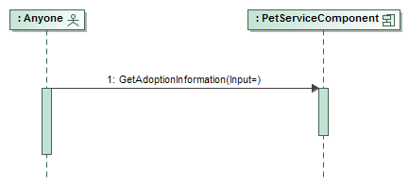
Figure 18 Pet Adoption Interaction
In the UML model, such Interactions are owned by the Collaboration that represents the subject community, and their Lifelines represent roles that the actors and components play in that Collaboration.
Together, these elements – the Collaboration, UseCases and Actors, Components, Ports, Interfaces and Interactions comprise the complete PIM for the example. This, on its own, is insufficient to generate the complete SSP. To complete the story it is necessary to provide annotations that add metadata sufficient for the generation task. These annotations are carried by UML InstanceSpecifications (which for readability we will call instances) whose types are classes in the GRA Annotations model specified in clause 9.
Figure 19 shows the annotations that primarily relate to the generation of the Service Description Document (SDD). The focus of this model is the Pet Adoption Service Description instance. The UML notation for an instance is a rectangle whose label contains the name of the instance, followed by a colon, followed by the type of the instance. In this case the label is Pet Adoption Service Description : ServiceDescription, indicating that the name is Per Adoption Service Description and the type is ServiceDescription.
The Pet Adoption Service Description realizes the Pet Adoption Community collaboration and uses the pet_adoption_iepd. In any GRA-UML PIM it is required that each ServiceDescription instance realizes a collaboration that represents its community, and uses one or more IEPDs that encapsulate its information model. The two-phase generation process uses the ServiceDescription instance to initiate the generation of all of the artifacts that will ultimately constitute the SSP.
In the main body of the Pet Adoption Service Description are a number of properties, in alphabetical order, together with their values in the form propertyname = value. Many of these properties have simple types: String, Integer, Boolean. For example, MajorVersion = 1 and ServiceNameAbbreviationText = “PET”. These property values flow through the generation process and find their place (or places) in the provisioned artifacts.
Linked to Pet Adoption Service Description are several other instances. In most cases, the link is also redundantly represented in the main body of Pet Adoption Service Description. For example the third property in the body appears as DataProvenance = Data Provenance. This is a redundant representation of the link depicted as a line between Pet Adoption Service Description and the Data Provenance instance, which also carries the property name DataProvenance.
Note: Depending on the tool being used, depicting such properties redundantly in the body of the instance may be a display option, which a user might choose differently.
Eight of these linked instances have the type Description: Additional Information, Purpose, Scope, Execution Context, Security, Privacy, Data Provenance and ServiceAssumption.
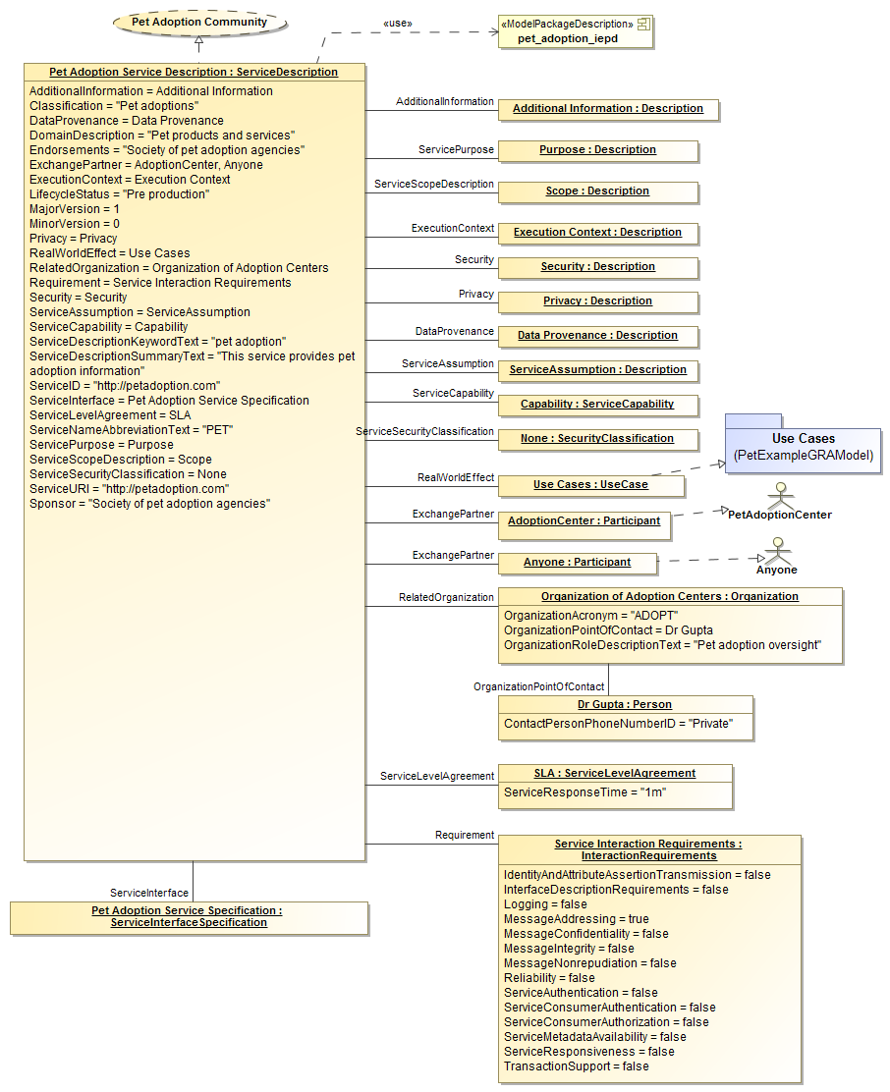
Figure 19 Service Specification annotation model
Although it is not shown on the diagram, each instance carries its own documentation. In UML terms, this is a single comment owned by the instance. Many UML tools have a special user interface to display this comment outside of the diagram. In the case of Data Provenance, the documentation comment is shown in Figure 20: this will flow through the generation process and ends up in the SDD’s Data Provenance section.
Figure 20 Data Provenance documentation
The class Description also provides the possibility for a property containing a URL of external documentation, which would be incorporated into the generated SDD. None of the instances in this example take advantage of this capability.
Other instances in the diagram have different types: Capability : ServiceCapability; None : SecurityClassification; Organization of Adoption Centers : Organization; Dr. Gupta : Person; SLA : ServiceLevelAgreement. Each of these provides metadata that flows through the provisioning process into the SDD documentation.
Some of the instances play especially important roles in the provisioning process. Service Interaction Requirements : InteractionRequirements provide top-level defaults for the interaction requirements, as described in section 7.4.5. They may be – and in this example will be – overridden at low levels of the hierarchy.
The RealWorldEffect property refers to the instance UseCases : UseCase. Notice that UseCases realizes the Use Cases Package in the PIM. The effect of this is that the Phase-1 generation will create a RealWorldEffect for every UseCase in that package. In fact there is only one - “Provide information on a particular pet adoption based on the ID of the adopting individual” – but if there were several UseCases in the package, then a RealWorldEffect would be generated for each of them. Don’t confuse the GRA Annotation class UseCase with the UML metaclass with the same name: the GRA Annotation UseCase instance is used to tell the generation process which UML UseCases in the PIM should be included in the output. For example, a model containing one annotation UseCase element that realizes a package containing three UML UseCases will cause the generation of three annotation UseCase elements in the intermediate annotations.xmi file, each referring to the corresponding PIM UseCase.
The ExchangePartner property refers to two instances of Participant called AdoptionCenter and Anyone, each of which realizes an Actor: AdoptionCenter realizes PetAdoptionCenter, and Anyone realizes Anyone. These ExchangePartners will appear in the intermediate annotations.xmi file. Just as for UseCases, an equivalent effect could have been produced by a single ExchangePartner realizing the Use Cases package. In that case, the Phase-1 generation would have looked for Actors in the package and generated an ExchangePartner for each Actor.
The final instance shown in Figure 19 is Pet Adoption Service Interface Specification : ServiceInterfaceSpecification. This is an elided representation of the ServiceInterfaceSpecification instance that is shown more completely in Figure 21. Remembering from section 7.1 that an SSP contains one SDD and one or more SIDDs, the annotation model must similarly contain one ServiceDescription and one or more ServiceInterfaceSpecifications.
Pet Adoption Service Interface Specification contains some properties with simple types, such as SecurityDescriptionText = “NONE”. It is linked to instances representing the ServiceInteractionProfile, the Service, and an overriding InteractionRequirements instance, in which the property ServiceAuthentication = true instead of the false value which would otherwise have been inherited from the top-level requirements.
Service instances are required to realize Components in the PIM, in order that the generation process can create the corresponding service hierarchy described in section 7.4.4. In this case, the single Service instance realizes the PetServiceComponent.
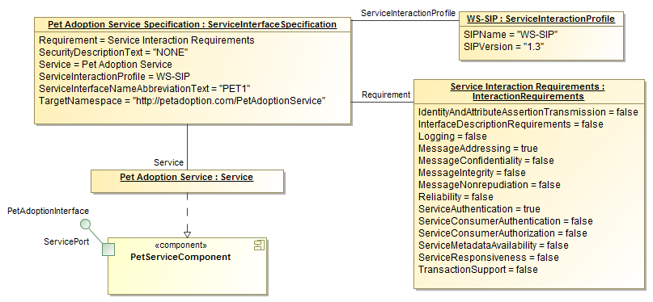
Figure 21 Service Interface Specification annotation model

Mappings to other specifications

(informative)
Will be provided in revised submission.

Machine Readable Files

Work-in-progress machine-readable files may be found at https://github.com/GRA-UML/specification/tree/master/GRAUML. This includes models, profile definition, examples, templates, schemas and transformations.
The revised submission will contain a complete inventory of normative, non-normative and ancillary machine-readable files.

